A Purchase Requisition process will be used for certain expenditures based on the type of expenditure and dollar amount.

#### Guidelines

1. All Purchase Requisitions must be approved in accordance with the published Levels of Authority before a commitment is made to a vendor. Refer to the **Authorizations Policy 400-1** for Authorized Levels of Authority.

2. A Purchase Requisition is required for non-SC inventory procurement.

3. A Purchase Requisition is required for purchases of non-inventory depreciable assets of $2,500 or greater.

This guideline provides detailed instructions on various categories surrounding a Purchase

Requisition.

* Creating a new Purchase Requisition
* Attaching support to a Purchase Requisition
* Adding a line to a Purchase Requisition
* Finding an Invoice Receipt (IR) number
* Release Strategy
* Processing a Goods Receipt (GR)
* Reversing a Goods Receipt (GR)
* Finding a Check Number
* Locating the Check Encashment Date
* Finding a vendor # with only the vendor name
* Finding a PO # with only a vendor #

**ME51N: How to create a new Purchase Requisition**

1. **Log into SAP**

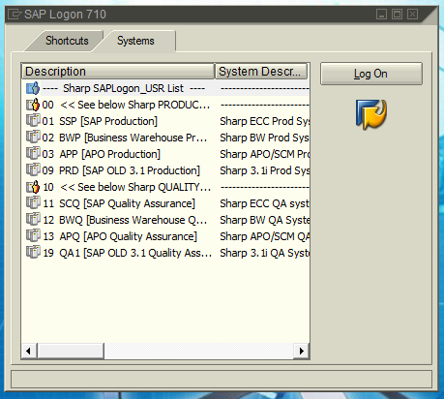

*Double click on SAP Production*

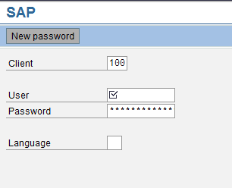

*Enter SAP user id and password and hit enter*

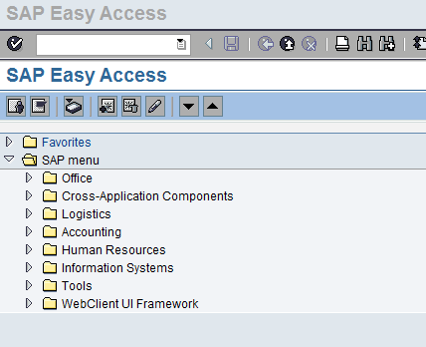

*Type ME51N in here*



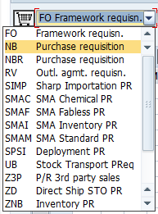

1) Use the drop down and choose “*Non Inventory PR*” or “*ZNB Inventory PR”* for third Party PR’s.



2) You can Enter *“****K****” Cost center,* ***X*** *3rd Party Processing* or***Z*** *Profit Center* under the accountassignment category field. You can also enter ***A*** *for Asset* (assets can be hardware/software that are under $25K; the asset # is assigned by Finance) or ***3*** *for CER - Internal Order* – this is for any purchases against a CER (Capital)

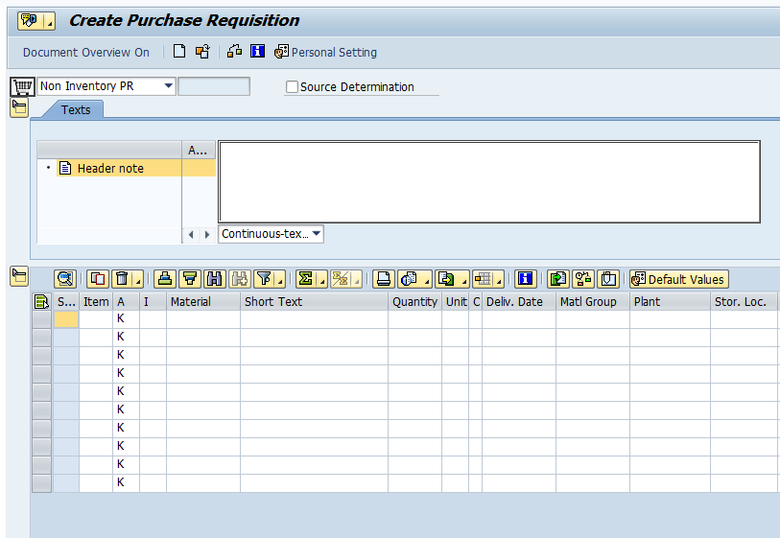

*Put a brief note here --- this is what goes in an e-mail to the person releasing the requisition*

3) Enter line item from Quote or a short description of what is going to be ordered in the “*Short Text*” field

4) Enter Quantity of *“****1****”* or greater because the price and quantity set out in the purchase requisition determine the value of the purchase requisition item or purchase requisition. In turn, this value is applied in determining the release strategy for the requisition.

5) Enter *“****EA****”* under the *Unit of Measure* field

6) Enter *Delivery date* on which the service is to be performed

7) Enter *the material group* if defined, otherwise enter *“****99****” No Material Group* under the *Material Group* field *if Non Inventory.*

8) Enter your Plant or Branch under the “*Plant*” field = MA01 or SB58, for example

9) Enter your Purchasing group: *“****B08 or B09****” if Corporate places the order or “****SNC****” for SBS North Carolina” for example*. You can click on drop down to find the one you needunder the *Purchasing Group* field

10) Enter your***SAP login***name under the *Requisitioner* field (***note***: it must be first maintained in the PR routing table by SEC Corp)

11) Enter the Vendor # under the *Fixed Vendor* field

12) Enter the *Purchasing Organization* under the *POrg,* for example***SHBS or SH01***

Now that all the above fields have been entered you can hit the *“****Enter****”* key on your keyboard. The “Create PR” screen will request that you enter a G/L account and Cost Center or Profit Center on the *Account Assignment* tab*.*

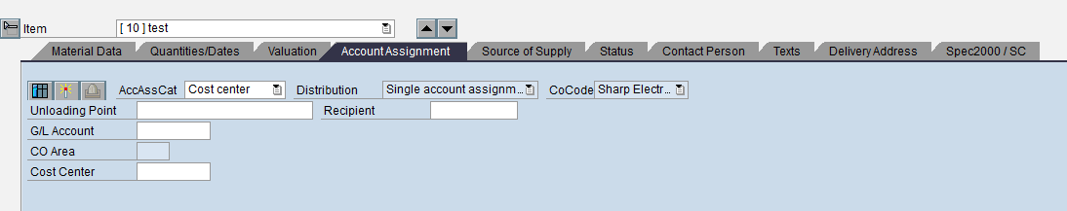

13) Enter *“G/L Account #”* under the *G/L Account* field

14) Enter *“Cost Center #”* under the *Cost Center* field or *“Profit Center #”*

Hit the *“****Enter****”* key on your keyboard. The Create PR screen will request that you enter a Valuation Price on the *Valuation* tab.

15) Enter *“Valuation Price”* under the Valuation Price field; this would be the price of the item without tax

*Example of a completed PR:*

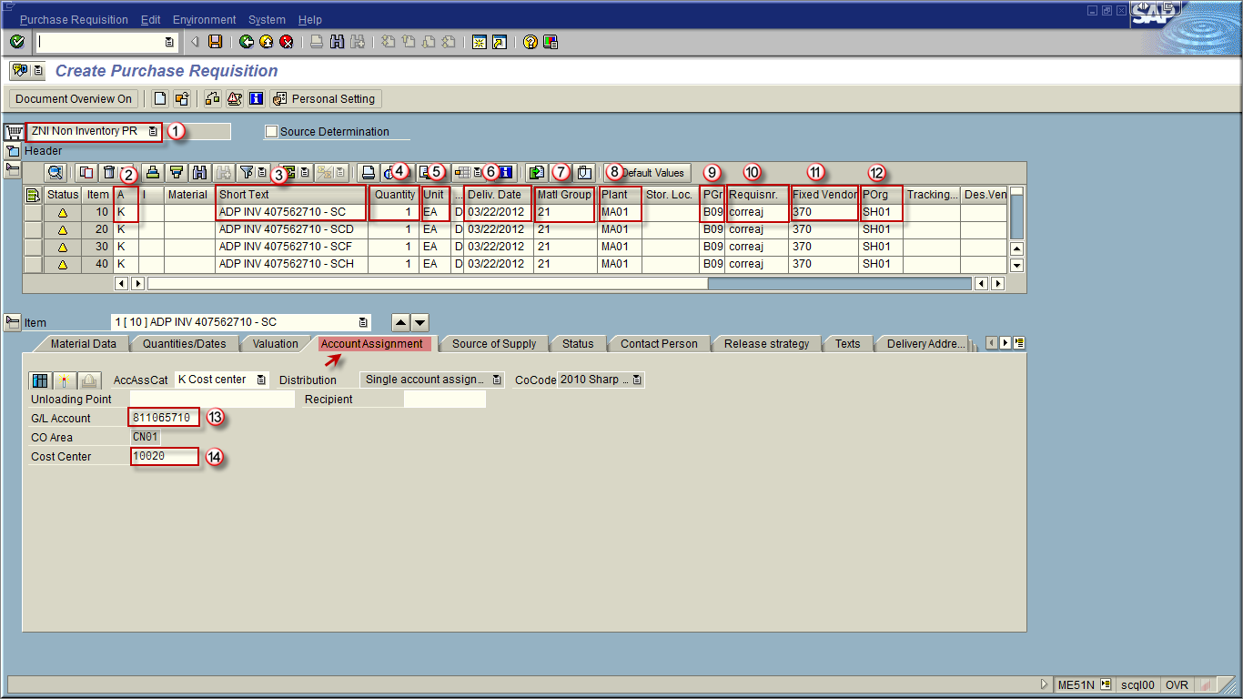

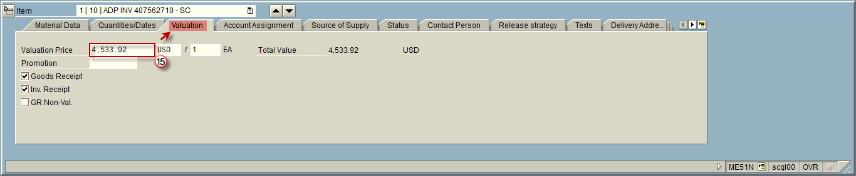

***Note***: You must inform the Purchasing Dept. if the order is taxable or non-taxable. If you are procuring inventory items that should not be taxed by the vendor, you must work with the vendor to complete the appropriate paperwork so the orders placed with them are tax exempt and the invoices are not taxed.

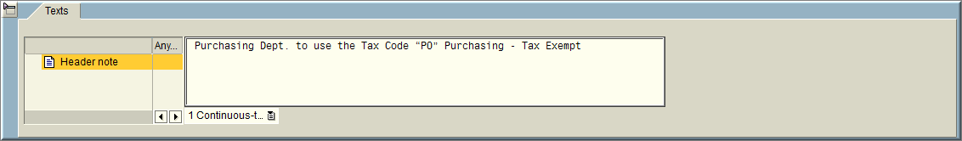

*Save the requisition and you will receive a PR #.*

**\*\*\* ATTACH DOCUMENT/INVOICE TO PURCHASE REQUISITION \*\*\*\***

**ME52N**

**Attaching an Invoice/Support to a Purchase Requisition**

After you have saved the PR, click on *Other Purchase Requisition*

**

Enter your *Purchase Requisition*number

Click on *Other Document*

**

Click on *Services for Object*  at the top left of the screen.

**

Click on *Create* ****, then click on *Store business document*in the drop-down.

**

Select the document type *Purchase requisition*.

**

You can now drag and drop your PDF file (the invoice) into the white space. You won’t know the file is there until you do Steps 6 and 7.

**

If you get a pop-up window, click on 

**

Enter a *Description*for your attachment

**

Click on *Continue*  or press *ENTER*.

**Note:** your document now displays in the pop-up window.

Click on *Continue*  or press *ENTER*.

**

Click on *Save* ****at the top of the screen if applicable

**Note:** a message displays, confirming that your changes have been saved.

**

*NOTE:* Docs can be added in “*Display Purchase Req*” mode also.

In Create mode, SAP doesn’t allow the attachment. Req must be saved first then you can go back in to add attachment.

**In order to view the attachment**:

*Click on the icon that looks like a little paper, or the drop-down box depending on the SAP GUI you have installed. Then click on Attachment List; double click on the attachment and it will open up*

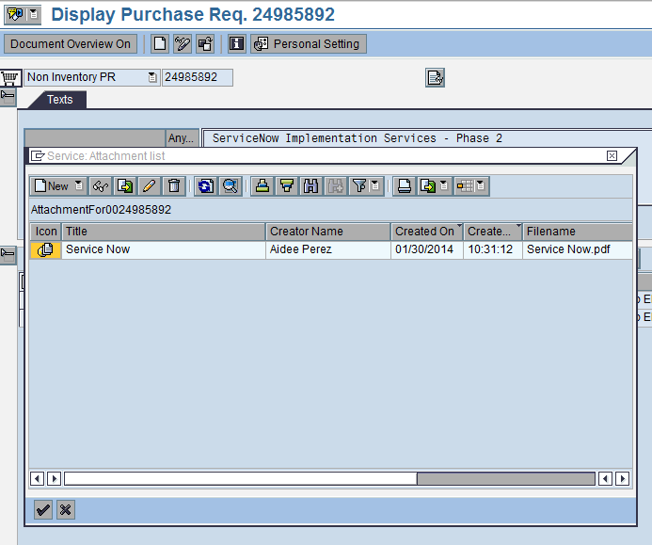

Now that all of the above fields have been entered you can follow the steps from 2-15 to enter any additional lines. Once completed with all line entries, you will need to click on the “Save”  icon to create your requisition and start the Workflow process to have your PR approved and released. The PR# will show up on the bottom left-hand side of the screen.

**To add a line to a PR:**



* Click the “deck of cards”

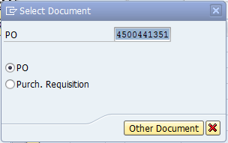

* Type in PO # and click “*Other Document*”
* 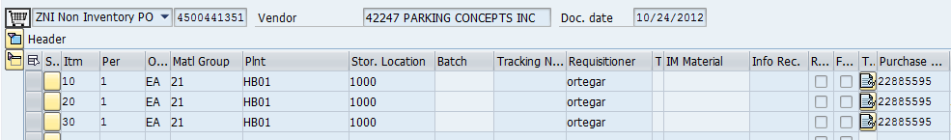Scroll over to find the PR# and double click

 **🡪** Click on the pencil and follow steps 2-15 above.

**Note**: Any changes to a PR will need to be made via transaction *ME52N* before the PR is approved and released.

**\*\*\*\* ATTACH DOCUMENT/INVOICE TO PURCHASE REQUISITION \*\*\*\***

**ME23N**

**How to find the Invoice Receipt Number (IR)**

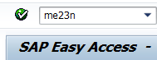

* Type in *ME23N* then click the green check or enter key



* Click the “*deck of cards*”

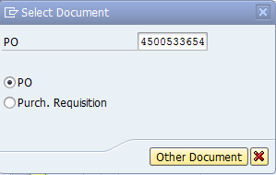

* Type in the PO and click “*other document*”

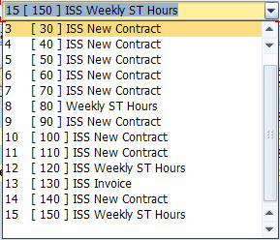

* Drop down to the line you processed the GR
* 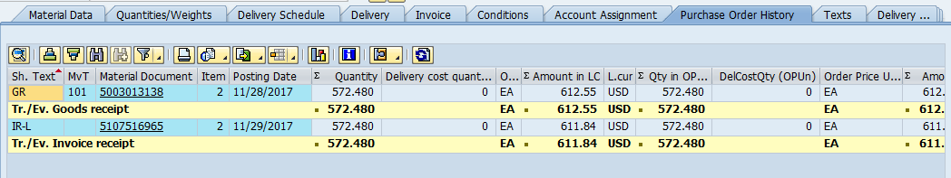Go to the “*Purchase Order History*” tab and you will find the IR#

**\*\*Goods Receipt starts with 500\*\***

**\*\*Invoice Receipt starts with 510\*\***

**ME23N**

**Release Strategy:** How to know when the PR was approved



* Type in *ME23N* and hit enter or green check



* Click the “deck of cards”

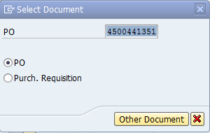

* Type in the PO# then click “*other document*”
* 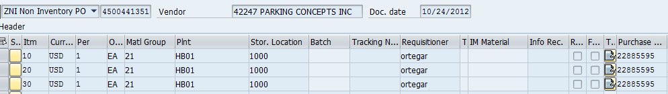Scroll over to the PR# and double click
* Click on the *Release Strategy* tab



* Should have all green check marks once approved

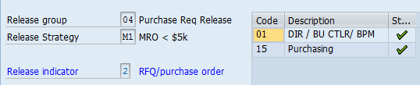

**Release Strategy:** How to look up the Purchase Order (PO#) once the Purchase Requisition (PR) is approved



* Type in *ME23N* and click enter or the green arrow



* Click the “*deck of cards*”

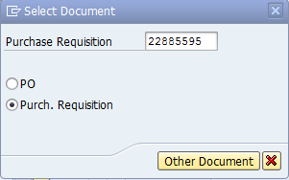

* Type in the *Purchase Requisition #*
* Go to the *Status* tab

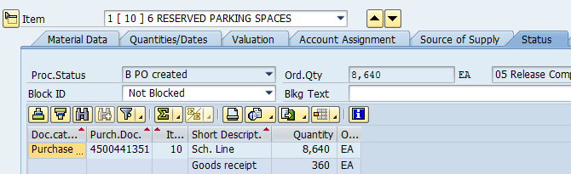

This is the PO #

**Release Strategy: How Purchase Requisition Approvers execute approval via workflow**

The step is for the Manager, Director or Sr. Director who will then process the work item found in his or her ***Inbox/Workflow*** folder by selecting the document and then clicking on the Execute  icon.

**Transaction: SBWP**

First you will go into transaction ***SBWP*** and select the below fields:

1. Select “*Inbox*” folder from the workplace menu
2. Select the “*workflow*” selection from the workplace menu
3. Select  line 01 for release
4. Click on the *Execute*  icon to process the line.
5. Click on the *release code 01 icon*  to process the line.
6. Select to validate if additional lines exist (optional) for your approval
7. Click on the “*Save*”  icon
8. Click on the “*Refresh*”  icon

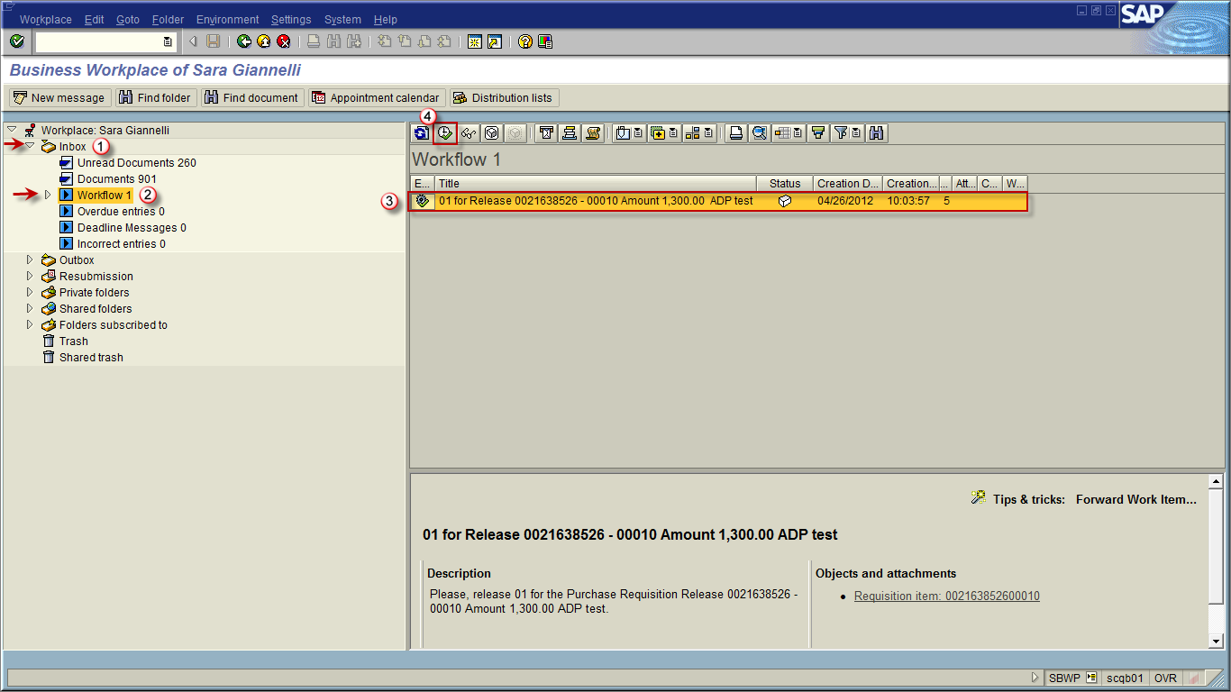

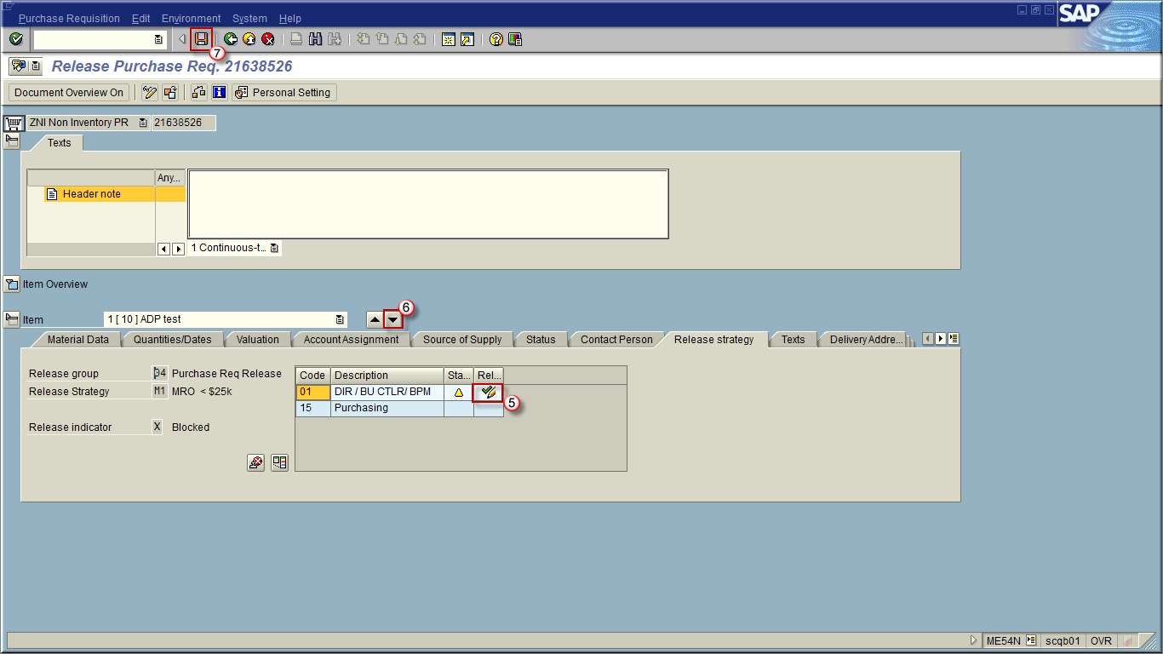

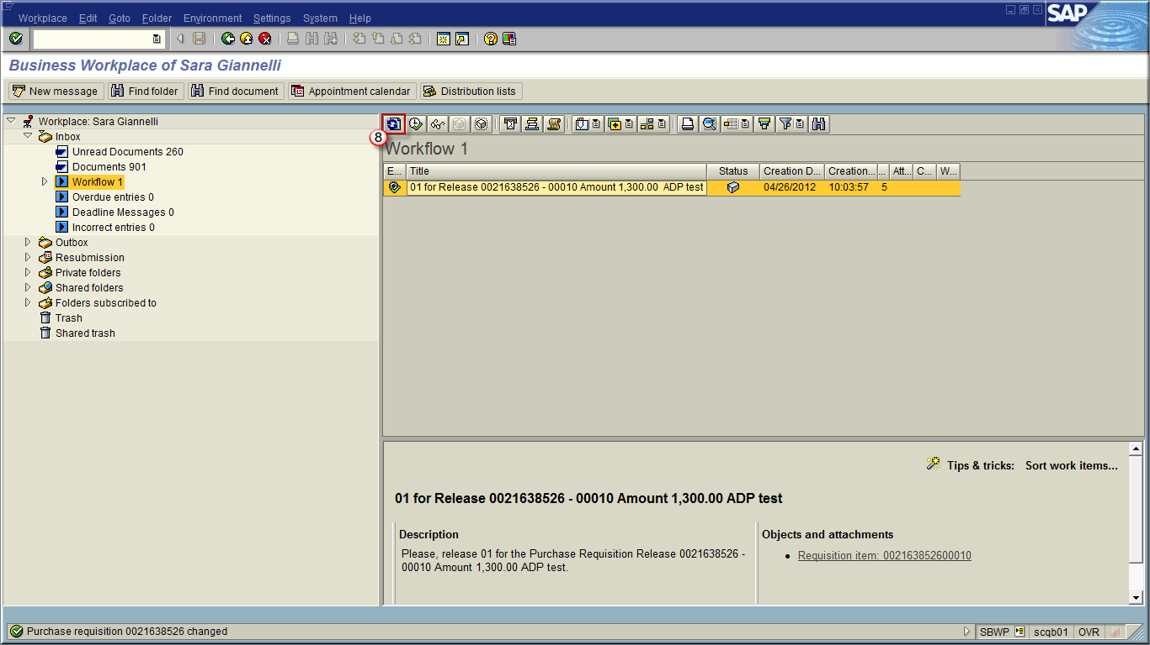

**MIGO_GR:**

**How to process a Goods Receipt (GR)**

It is a requirement to have the Purchase Requisition converted to a Purchase Order. Once the PR has been approved / released, it will be converted to a PO by the Purchasing dept. or automatically depending on the type. The PO will need to have a Goods Receipt in order for Accounts Payable to do an invoice verification and pay the vendor.

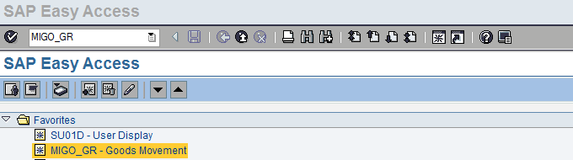

*Enter MIGO_GR and hit enter*

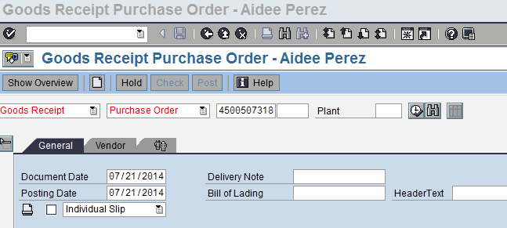

*NOTE: in the GR screen, it is usual for the invoice # and invoice date to be in the HeaderText box. Doing so helps clarify when doing a payment search, especially for POs that are often re-used for new line items.*

*Enter PO # here and hit enter*

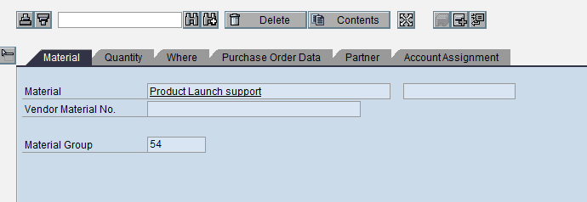

*Select “****Quantity****” tab and change the “6” to a “1” (this is for one month of charge --- the next time you get an invoice this number will be a “5” and you would change it again to a “1”) and hit enter.*

*Then click in the square next to “****Item OK****” so there is a check mark*

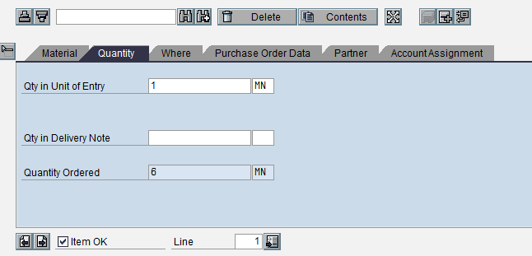

Invoices must be sent to IPS directly. You must note the PO #, line #, GR # and Amount to be paid on the invoice sent to IPS. You should also circle the invoice # and invoice amt on the invoice.

*Hit* ***Save*** *and you will see a GR # on the bottom of the screen. Write this number down and send invoice to IPS for processing*

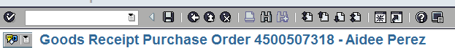

**How to reverse a Goods Receipt (GR)**

**🡪** Type in *MIGO_GR* and press enter or the green check

* Change *101 to 102*



* 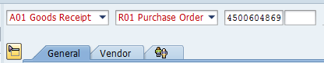Click the green check
* Enter PO#

🡪 Click green check again

🡪Highlight the last line

* 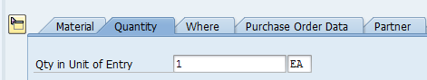Go to the *Quantity* tab and put the amount you want to reverse



* Check *Item OK* and then the little box



* click *Save* and the new GR will appear on the bottom left of the screen

**\*\*\*\*\* MAKE SURE TO CHANGE 102 BACK TO 101 \*\*\*\*\***

**FBL1N**

**How to find a check number** (This requires special authorization – not everyone can do this)

* Type in *FBL1N* and click enter
* 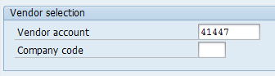Type in the vendor # in the *Vendor account line*
* 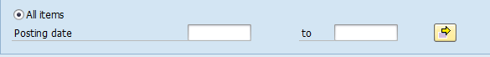Click the circle that says *All Items*



* Click the *clock* in the top left corner
* Scroll down until you find the amount/ IR / Reference# (Invoice #) you are looking for and double click on it to open it



**How to find if the check was cashed**

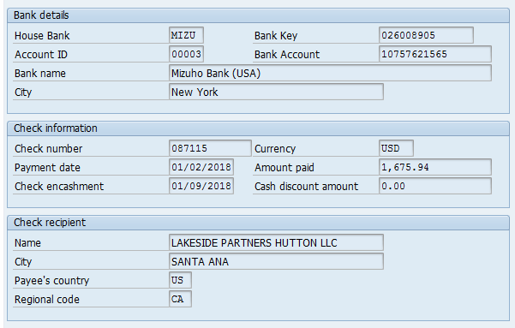

* Double click on the check number, click “*environment*” on the top banner, drop down and click “*check information*”

**Check was cashed on 1/9/18**

*NOTE:* Payments made by ACH will have a clearing date instead of a check number and encashment date

**FK03: How to find a vendor number with only the vendor name**

**NOTE:** There is usually more than one vendor # for the same vendor name depending on the state. You can confirm you are picking the correct one by checking the zip code.





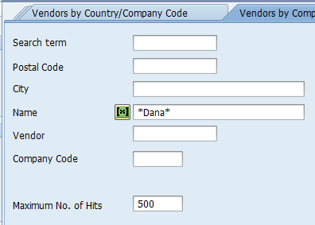

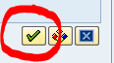

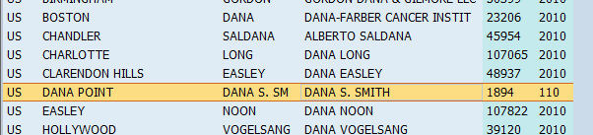

**FBL1N: How to find a PO number with only a vendor number**

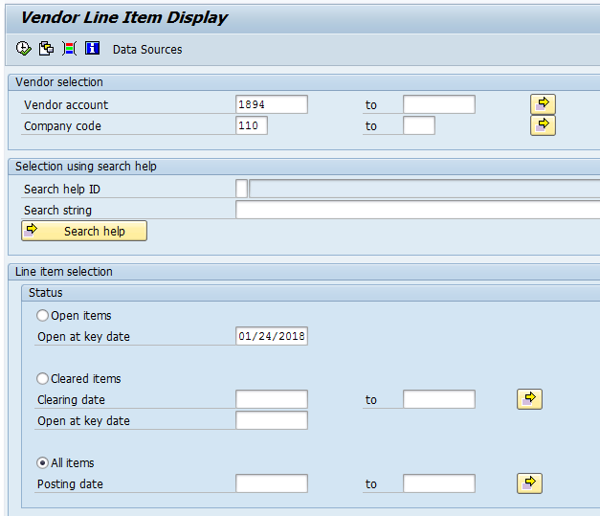

**\*\***Double click on an *IR number*- then this screen will show up**

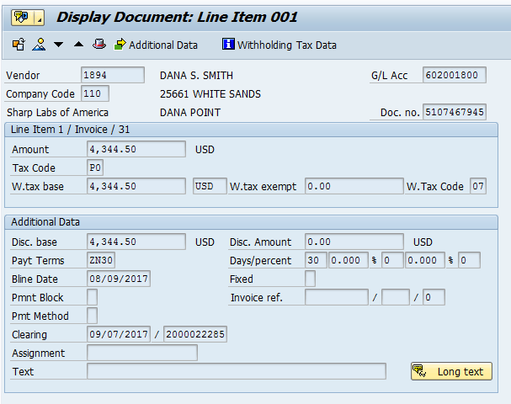

Highlight the*clearing number*

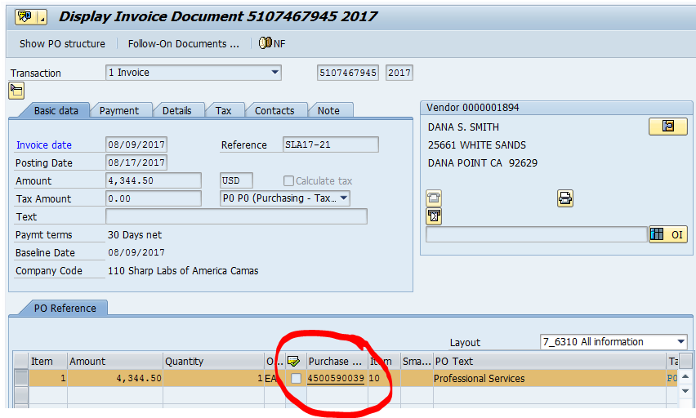**On the top border- click the *Environment tab 🡪 Document environment 🡪 Original document*